**TEST AUTOMATION REPORT**

**TESTCASES**

**TC001**

**User able to create username and password**

**test_createAccount**

**Script:**

sp = SignInPage(self.driver)

sp.go_to_signin()

sp.enter_user("H1708")

sp.enter_passwd("H1708")

sp.create_account()



**TC002**

**User able to save Personal Info**

**test_settingsPersonalInfoSave**

**Script:**

setp = SettingsPage(self.driver)

setp.edit_personal_info()

setp.fname("Hardik")

setp.dob("08172001")

setp.gender("female")

setp.mobile("9876543210")

setp.address("subhash nagar")

setp.save()

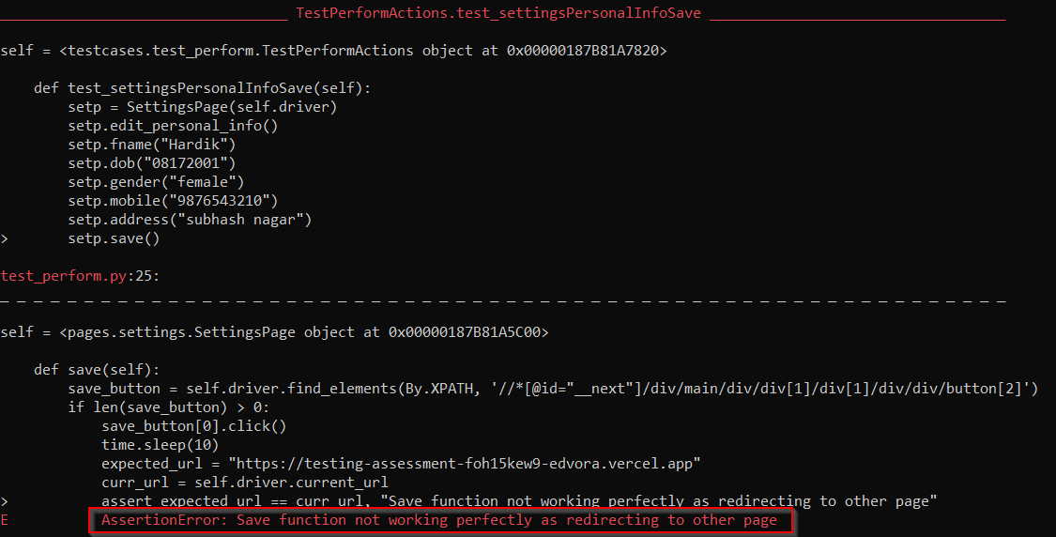

**TC003**

**User able to cancel Personal Info**

**test_settingsPersonalInfoCancel**

**Script:**

sp = SignInPage(self.driver)

seto.back_to_url()

setp.cancel()



**TC004**

**User able to edit and save changed password**

**test_settingsSecuritySave**

**Script:**

sp = SignInPage(self.driver)

setp.edit_security()

setp.change_password("h1708")

setp.save_security()



**TC005**

**User able to cancel password change**

**test_settingsSecurityCancel**

**Script:**

setp = SettingsPage(self.driver)

setp.cancel_security()



**TC006**

**User able to logout of settings page**

**test_settingsLogout**

**Script:**

setp = SettingsPage(self.driver)

setp.logout()



**TC007**

**User able to login with created username and password**

**test_login**

**Script:**

lp = LoginPage(self.driver)

lp.enter_user("H1708")

lp.enter_password("H1708")

lp.login()

lp.assert_url()

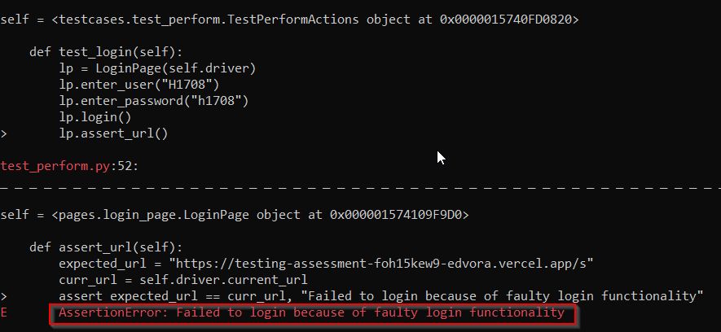

**BUG REPORT**

Test case Number – **TC007**

Bug number – **001**

Bug title – **User unable to login**

Steps to reproduce bugs

1. Go to Login page URL - <https://testing-assessment-foh15kew9-edvora.vercel.app/>.
2. Input required fields.
3. Click on “login”.
4. Observe an alert showing something went wrong.

Test case Number – **TC002**

Bug number – **002**

Bug title - **Save button redirecting to external site**

Steps to reproduce bugs

1. Go to create account page and enter required fields.
2. Click on “create account”.
3. The page will be redirected to settings page
4. Click “edit” button under personal info.
5. Make changes to desired fields.
6. Click “Save”
7. Observe that the save button redirects to an external site